**LAB 02**

**Task# 01:**

Write a program that converts a positive integer into the Roman number system. The Roman number system has digits I (1), V (5), X (10), L (50), C(100), D(500) and M(1000). Numbers up to 3999 are formed according to the following rules:

1. As in the decimal system, the thousands, hundreds, tens and ones are expressed separately.
2. The numbers 1 to 9 are expressed as: 1 I 6 VI 2 II 7 VII 3 III 8 VIII4 IV 9 IX 5 V (An I preceding a V or X is subtracted from the value, and there cannot be more than threeI’s in a row.)
3. Tens and hundreds are done the same way, except that the letters X, L, C, and C, D, Mare used instead of I, V, X respectively.

Example: Your program should take an input, such as 1978, and convert it to Roman numerals, MCMLXXVIII.

**CODE:**  
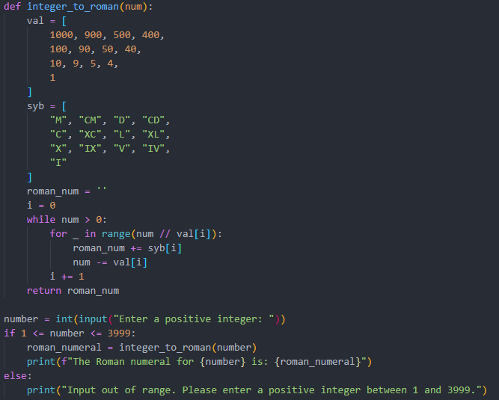

**OUTPUT:**



# Task# 02:

Write a program that calculates the user’s body mass index (BMI) and classify it as underweight, normal, overweight, or obese, based on the table from the United States Centers for Disease Control.

**CODE:**  
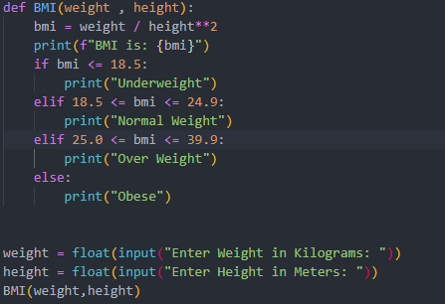

**OUTPUT:**

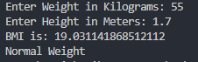

# Task # 03:

Write a program to compute quotient and remainder of a number without using division ('/') operator and modulo ('%') operator. Also mention procedure for calculating**.**

**CODE:**

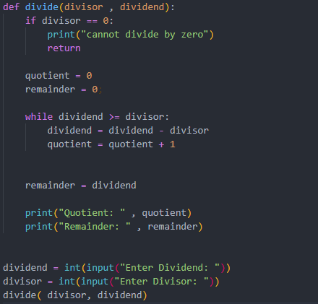

**OUTPUT:**

